**SYSTEM ARCHITECTURE:**

The architecture for the barcode scanning app will be pretty simple as the homepage of the app will ask user for login details as email and password. Once you enter your email and password correct than you will be allowed the access of the app. Upon getting the access, you can use the app to scan the barcodes. Sometimes, system might not be able to read the barcode or if the barcode is damaged then there will be an alternative for that; you can manually scan the barcode by clicking on the “enter barcode manually”. Once the barcode is successfully scanned the data will be stored in data repository.

Below is the diagram for the system architecture of app.

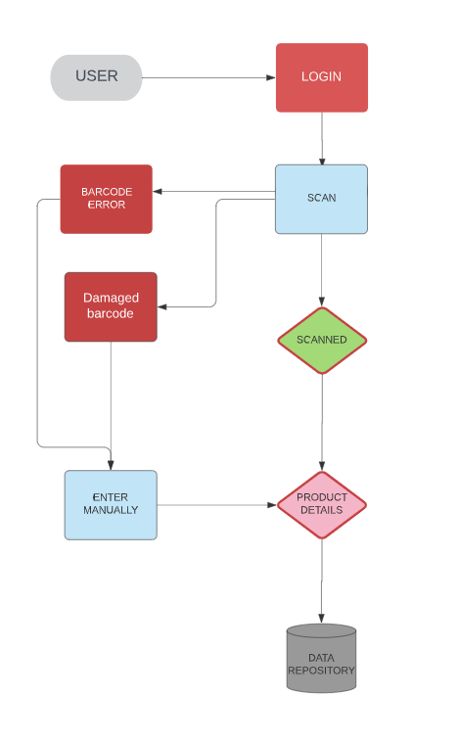

**SYSTEM CONTEXT:**

This will be a barcode scanning app where barcodes of the products will be scanned and the data will be saved in data repository. The app will be capable of reading the barcodes from tags on the clothes.

**THE HARDWARE REQUIREMENTS** for this app will be the mobile can be connected to internet so the app can be downloaded in the system and the second and most important requirement is that it should have a clear vision camera which can easily identify the barcode, hence the app will be working on non-camera mobile phones or tablets but the condition is that you have to enter all the details manually.

**THE SOFTWARE REQUIREMENTS** will be, mobile phone or tablet should be android or IOS in order to run the app. There should be enough memory in the phone to get the app downloaded.